**BP NEURAL NETWORK EMPOWERMENT: A BREAKTHROUGH IN RADAR SIGNAL CLASSIFICATION**

**Yang Hua Liang**

College of Electronic Science, National University of Defense Technology, Changsha, China, 410073

**Abstract:** As science and technology continue to advance, radar systems have expanded their utility beyond everyday applications, playing an increasingly pivotal role in modern warfare [1]. The precise and efficient identification of radar signals carries profound implications, impacting areas such as missile warning, atmospheric detection, and target tracking [2]. Consequently, this paper delves into the challenge of radar signal identification and classification.

Numerous studies have explored the theme of "identification and classification of radar signals in complex environments." Li YJ introduced an integral rotation factor and devised a radial integration method, which, while creative, exhibits sensitivity to noise and reduced recognition accuracy at low signal-to-noise ratios. HU H took a distinct approach, employing spectral correlation analysis and the Gaussian kernel-support vector machine as a classifier for radar signal recognition, yielding enhanced robustness [4]. Dudul ventured into the realm of neural networks for the classification of radar echo signals in ionospheric studies, offering innovative ideas. However, the method's limited generalizability and susceptibility to interference remain drawbacks [5]. Iglesias adopted an automatic modulation classifier characterized by low-complexity signal features and hierarchical decision trees, boasting efficiency and immediacy as advantages [6]. WANG Y C leveraged the Morlet method, employing wavelet ridges as features for radar signal classification after signal wavelet transformation. Yet, this technique presents computational intensity and reduced recognition efficiency [7]. WANG Q integrated a convolutional neural network with a bidirectional long and short-term memory network, achieving higher recognition success rates. However, the introduction of radar signal types led to a significant decrease in classification accuracy [8].

In sum, while existing methods yield promising outcomes in signal classification, they grapple with challenges related to poor immunity against interference and limited classification accuracy under conditions characterized by low signal-to-noise ratios.

**Keywords:** Radar Signal Identification, Signal Classification, Signal-to-Noise Ratio, Machine Learning, Interference Immunity

### 1. Introduction

With the development of science and technology, radar can not only benefit human beings in daily life, but also play an indispensable role in modern warfare [1]. If the radar signals can be identified accurately and efficiently, it will have a profound impact on the research in the fields of missile warning, atmospheric detection, and target tracking [2]. Therefore, this paper addresses the problem of radar signal identification and classification.

A lot of research has been done on the topic of "identification and classification of radar signals in complex environments". Li YJ [3] introduced an integral rotation factor, and used a radial integration method creatively. However, this method is sensitive to noise, and the recognition accuracy is low at low signal-to-noise ratio. HU H [4] applied spectral correlation analysis and used Gaussian kernel-support vector machine as a classifier for radar signal recognition, which has better robustness and robustness. Dudul [5] used neural networks to classify radar echo signals in ionospheric studies with novel research ideas. However, the method is not generalizable and less resistant to interference. Iglesias [6] used an automatic modulation classifier with low complexity signal features and hierarchical decision trees, which has the advantage of efficiency and immediacy. WANG Y C [7] used Morlet method, which uses wavelet ridges after signal wavelet transform as features for radar signal classification. However, this method is computationally intensive and has low recognition efficiency. WANG Q [8] linked convolutional neural network with bidirectional long and short-term memory network and obtained higher recognition success rate. However, if the radar signal type is added, the classification accuracy decreases significantly.

In summary, the existing methods can achieve good results for signal classification, but there are still problems of poor interference immunity and low classification accuracy under low signal-to-noise ratio conditions.

In order to improve the accuracy of radar signal identification and classification, combining the valuable experience of previous authors, this paper proposes a radar signal classification method. First, constructing the complex echo signals and implementing the normalization process on the spectrum of the echo signal. Second, calculating the PSD of different echo signals, taking the sub-band power ratio as the feature parameter. Finally, the BP neural network is used for classification. The classification results of this paper were compared and analyzed with the traditional single-layer neural network recognition method. All in all, this method has higher recognition accuracy and stronger anti-interference ability.

### 2. Feature extraction based on PSD of radar signals

Common signal feature extraction methods include: extraction of signal over zero rate; calculation of signal short-time energy and short-time autocorrelation function; calculation of frequency standard deviation; extraction of resonance peaks, etc. In this paper, the PSD of the radar echo signal is characterized by feature extraction, which has low execution complexity, significant signal characterization, and strong resistance to environmental interference.

#### 2.1 Constructing demodulated echo signals

To the beginning, in practice, the radar transmits a real signal, but the signal is artificially demodulated in two ways to construct a complex echo signal [9]. In the conventional method, the radar will mix the received signal to obtain a demodulated echo signal consisting of two echoes of I, Q.

The linear frequency modulated signal (LMF) is one of the pulse compression techniques, which is very important in practical applications and can effectively solve the contradiction between the distance of action and the distance resolution of the radar system. The LMF signal is easy to generate and process, and is technically mature. Besides, its instantaneous frequency is a linear function of time, and a uniform signal bandwidth can be obtained, which has been widely used.

Taking the classical LMF signal as an example, its radar emission signal can be expressed as

𝑥𝐿𝐹(𝑡) = cos[2𝜋𝑓0𝑡 + 𝑘𝜋𝑡2] [𝑢(𝑡) − 𝑢(𝑡 − 𝜏𝑝)] (1)

The carrier signal of I channel is cos(⁡ 2𝜋𝑓0𝑡), the carrier signal of Q channel is ,and the constructed complex demodulated echo signal is 𝑦𝐼(𝑡) and 𝑦𝑄(𝑡).

𝑦(𝑡) = 𝜎𝑐𝑜𝑠[2𝜋𝑓0(𝑡 − 𝑡0) + 𝑘𝜋(𝑡 − 𝑡0)2] 𝑐𝑜𝑠(2𝜋𝑓0𝑡)

𝑐𝑜[−2𝜋𝑓 0𝑡0 + 𝑘𝜋(𝑡 − 𝑡0)2] + 𝑐𝑜𝑠⁡(4𝜋𝑓0𝑡 − 2𝜋𝑓0𝑡0 + 𝑘𝜋(𝑡 − 𝑡0)2) (2)



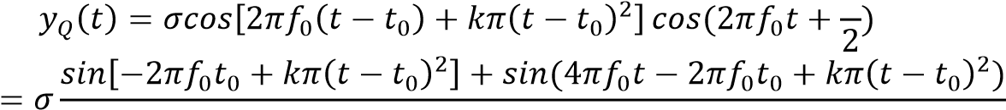 (3)



As the second term in the expression of the two-way echo signal is much higher in frequency than the first term in practical applications, the second term can be filtered out by a low-pass filter, so the demodulated echo signal can be expressed as⁡𝑦(𝑡).



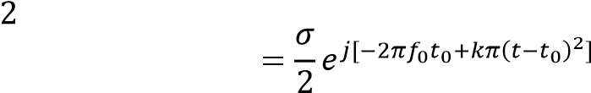 (4)

#### 2.2 Calculate the PSD of the echo signal

In the frequency domain of the discrete time Fourier transform (DTFT). Formally, the sequences at both ends of the transform (in the time and frequency domains) are finite-length, while in practice both sets of sequences should be considered as principal value sequences of discrete periodic signals. For a finite-length discrete signal to be DFT, it is usually considered as a periodic signal that has been periodically extended and then transformed.

After obtaining the radar echo signal, this paper uses DFT to calculate the PSD of the echo signal.

The basic formula of DFT is as follows:

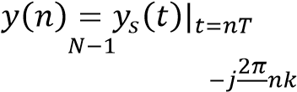 (5)

𝑦(𝑘) = ∑ 𝑦(𝑛)𝑒 𝑁

𝑛=0  is the sampling period.

In our experiment, the DFT of the echo signal was done with N=2024. In order to facilitate the extraction of classification features, the DFT spectrum of the echo signal was normalized before obtained its PSD. Figure 1 shows the normalized PSD image of the classical LMF signal.

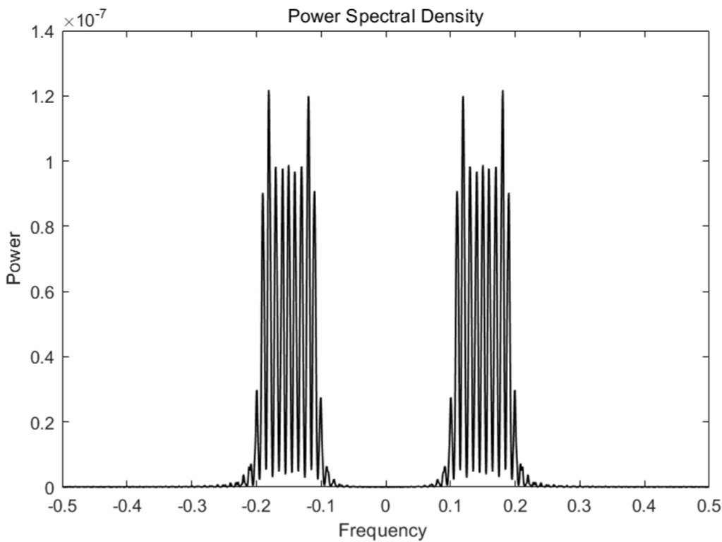

Figure 1: PSD image after normalization of classical LMF signal

In this paper, we took the positive semi-axis region of the normalized PSD image and divided it uniformly into five intervals. Each interval is called a sub-band, and the power ratio 𝐺𝑖⁡of sub-band  was calculated as follows [10].

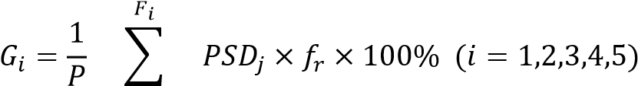

𝑗=(𝑖−1)∗𝑢 𝐹5 (6)

𝑃 = ∑ 𝑃𝑆𝐷𝑗 × 𝑓𝑟

𝑗=0

𝐹𝑖denotes the cutoff frequency of sub-band , 𝑓𝑟 is the frequency resolution, 𝑃𝑆𝐷𝑗 is the power spectral density at frequency , and 𝑃⁡is the total power.

The power ratios of these five intervals are used as classification features for the BP neural network. In this paper, five common radar signals [11] were used, as followed: rectangular pulse signal (CP), linear frequency modulated pulse signal (LMF), binary phase shift keying pulse signal (BPSK), Frank multiphase coded signal (Frank) and Costas signal.

### 3. Construction of BP neural network classification system

The common classifiers for radar signals are neural networks, Gaussian kernel-support vector machines, random forests, etc. BP neural network, a classifier with strong nonlinear mapping and fault tolerance capabilities, has high adaptability to our data. As a result, we chose BP neural network as the classifier for this paper.

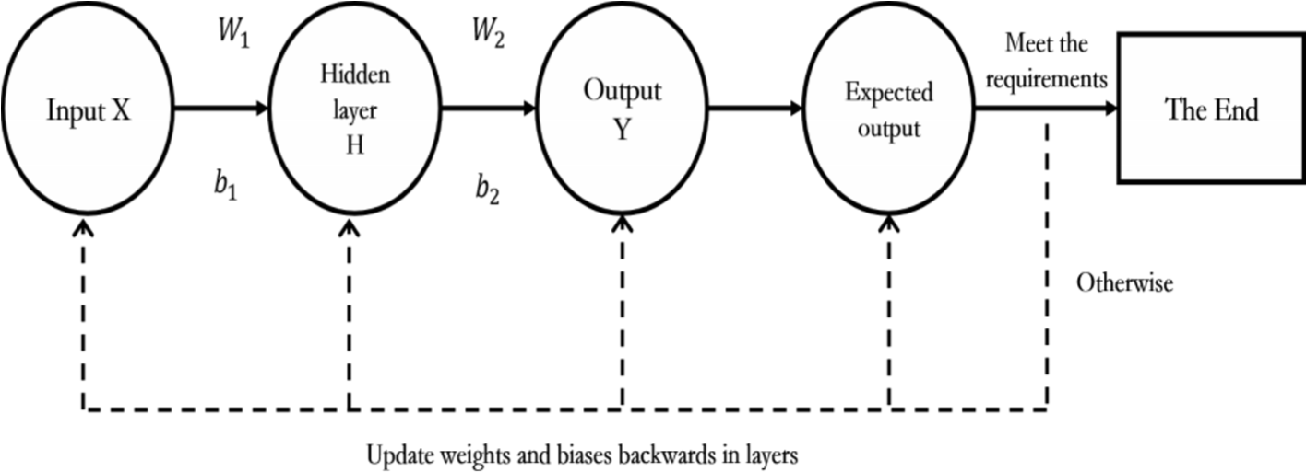

Figure 2: Schematic diagram of BP neural network

BP neural network is trained by computer simulation on the basis of raw data to obtain classification rules. It can get the closest result to the desired output value for the given input value. Its main feature is that the signal propagates forward through the weights 𝑤𝑖, while the error propagates backward through the feedback 𝑏𝑖. The schematic diagram of BP neural network is shown in Figure 2.

#### 3.1 Forward propagation of the signal

In a BP neural network, numerous neurons form a hidden layer with a multilayer structure. Each neuron receives input signals from other neurons, which are weighted to obtain a total input value. The neuron compares the total input value with a threshold value, and then the value will be processed by an activation function to obtain the final output [12].

The introduction of the activation function can solve the linear indistinguishability problem and strengthen the expressiveness of the deep neural network [13]. In forward propagation, information enters the network from the input layer and is computed at each layer of the implicit layer in turn to obtain the result of the final output layer. The structure of signal forward propagation is shown in Figure 3.

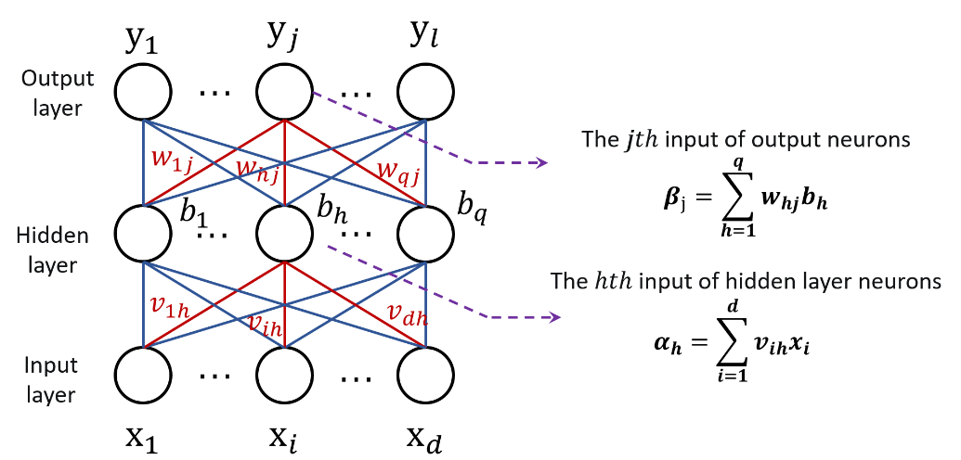

## Figure 3: Forward propagation of the signal

We multiply the value of each layer by the corresponding weight and bias variable as the activation function.

From the input layer to the hidden layer, it can be expressed as:

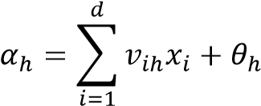 (7)

From the hidden layer to the output layer, it can be expressed as:

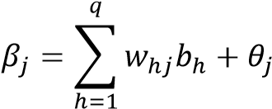 (8)

Due to the random parameters, there is a large error between the first output and the real result. The back propagation of the model adjusts the parameters according to the error, and as a result, the parameters can be better fitted until the error reaches a minimum value.

#### 3.2 Back propagation of errors

Back propagation makes the error smaller by calculating the error between the output value and the true value, spreading the error among all neurons in each layer, and using the error signal obtained from each layer as the basis for adjusting each parameter.

The formula for calculating the error is as follows:

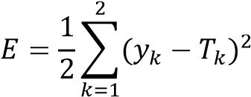 (9)

𝑦𝑘 is the output value and 𝑇𝑘 is the true value.

The basic idea of BP neural network to reduce the error is using gradient descent method. The neural network uses gradient search to adjust the connection strength and the threshold value of the nodes between the input layer and the hidden layer and the hidden layer and the output layer. As a result, the error decreases along the gradient direction.

The formula for reverse update of weights is as follows:

Δ𝑤𝑖𝑗 = (𝑙)𝑦𝑘

(10)

𝑤𝑖𝑗 = Δ𝑤𝑖𝑗 + 𝑤𝑖𝑗

 is called the learning rate, which can adjust the pace of updating, generally taken as 0.1-0.6.

The steps of BP neural network implementation are as follow.

First, it calculates each neuron input and output. Second, it calculates the partial derivative of the error function with respect to each output layer neuron. Third, it calculates the partial derivative of the error function with respect to the hidden layer neuron. Then, it uses the results of the first two steps to correct the weights, and uses the learning rate to correct the network parameters. The global error is calculated to decide whether the requirements are satisfied. Finally, after several learning trainings, the mean squared error is minimized and the network parameters corresponding to the minimum error are obtained.

At this point, the BP neural network is able to process the input information and output the classification results with minimum error after nonlinear transformation.

### 4. Experimental results and analysis

#### 4.1 Experimental parameters design

In order to match the simulation with the actual electromagnetic environment, the parameters of the signal simulated in this paper were randomly transformed in the specified range. (𝑎, 𝑏) indicates that the corresponding parameter values are uniformly distributed in the interval from  to . The sampling frequency 𝑓𝑠 = 65𝑀𝐻𝑧, 𝑓𝑝, 𝑓1, 𝑓2 indicate the carrier frequency of the signal, 𝜏𝑝𝑤 indicates the pulse width of the signal,  indicates the coding length,  indicates the number of codes, and  denotes the bandwidth.

The main parameters of the signal and the characteristic parameters sub-band power ratio are shown in Table 1 and Table 2, respectively.

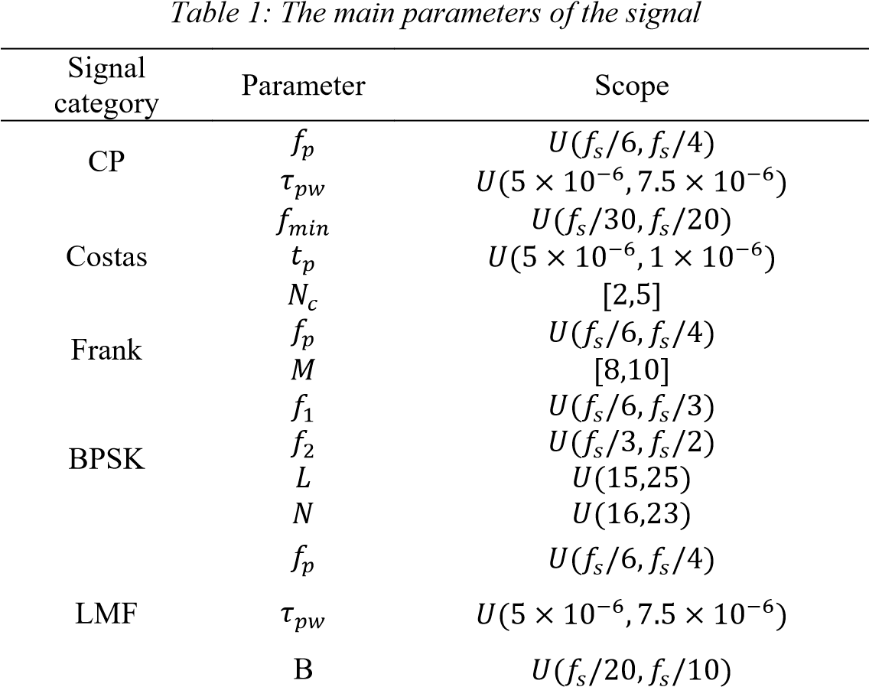

*Table 2*

*:*

*Sub*

*-*

*band power ratio of radar signal*

Signal

category

Sample

𝐺

1

𝐺

2

𝐺

3

𝐺

4

𝐺

5

CP

160

0.9980

0.0012

0.0005

0.0003

0.0002

Costas

160

0.2646

0.3435

0.2525

0.1393

0.1274

Frank

160

0.2935

0.2432

0.2236

0.2398

0.1447

BPSK

160

0.2133

0.2867

0.2842

0.2158

0.0853

LMF

160

0.0207

0.9524

0.0254

0.0015

0.0010

#### 4.2 Experimental results and analysis

We generated simulated signals with 160 samples for each signal, and superimposed Gaussian white noise with a signal-to-noise ratio of 2 dB. 800 total samples were divided into training and test sets according to 7:3, and the classification prediction was performed by BP neural network after feature extraction. The success rate of classification results and the confusion matrix of the test set are shown in Table 3 and Figure 4, respectively.

## Table 3: Classification results (2dB)

Signal category Recognition rate/%

|  |  |
| --- | --- |
| CP(y1) | 90.5 |
| Costas (y2) | 94.4 |
| Frank (y3) | 92.9 |
| BPSK (y4) | 92.0 |

LMF (y5)

90.9

*Figure 4*

*:*

*Confusion matrix for test data*

*(2*

*dB*

*)*

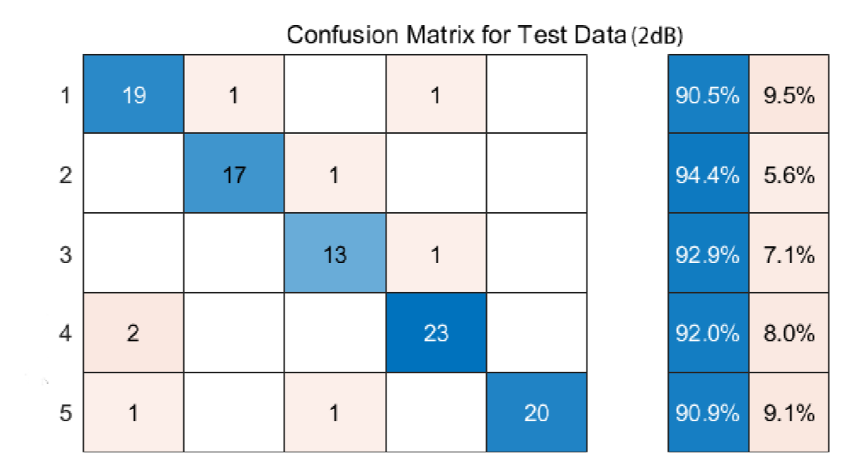

In addition, in order to test the classification system's resistance to interference, 800 samples were also assigned with equal probability between signal-to-noise ratios of -2 ~10 dB in this paper, and the image of the change in the accuracy of the classification system was recorded as shown in Figure 5.

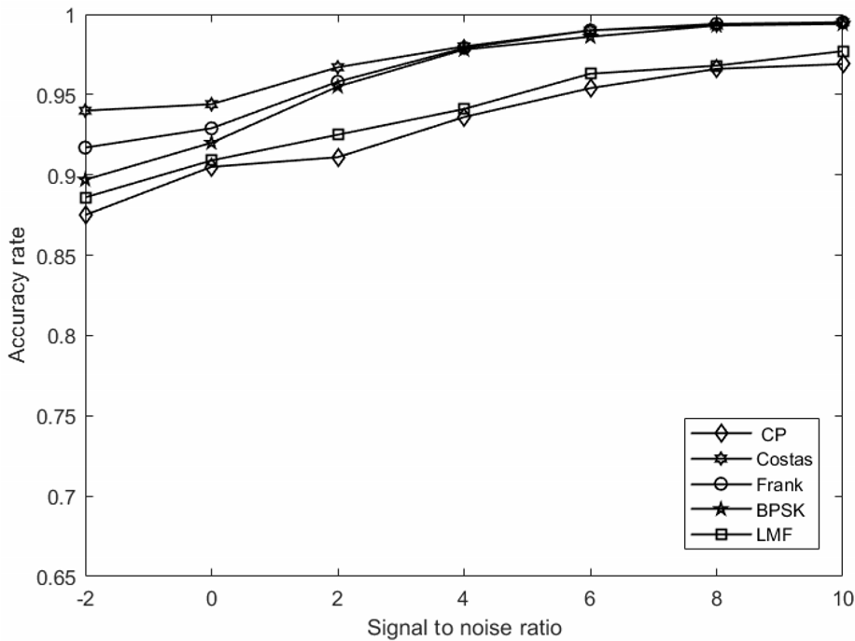

## Figure 5: Recognition result of BP neural network

In order to evaluate the classification system's ability, this paper replicated the single-layer neural network studied in the literature [14]. Its main feature is that the affine transformation will be performed before using the activation function in the output layer, which allows it to classify a wider range of classification classes.

In this experiment, we input the same radar signals and overlaid the same Gaussian white noise to the system constructed in the literature [14], and the accuracy of the single-layer neural network in classifying the radar signal was tested at 2 dB intervals between signal-to-noise ratios of 2 ~10 dB. Figure 6 shows the variation lines of classification accuracy between the BP neural network classification method in this paper and the single-layer neural network classification method in the literature [14] (the black line is the BP neural network classification result and the blue line is the single-layer neural network

classification result).

*Figure 6*

*:*

*Comparison of results between BP neural network and monolayer neural network*

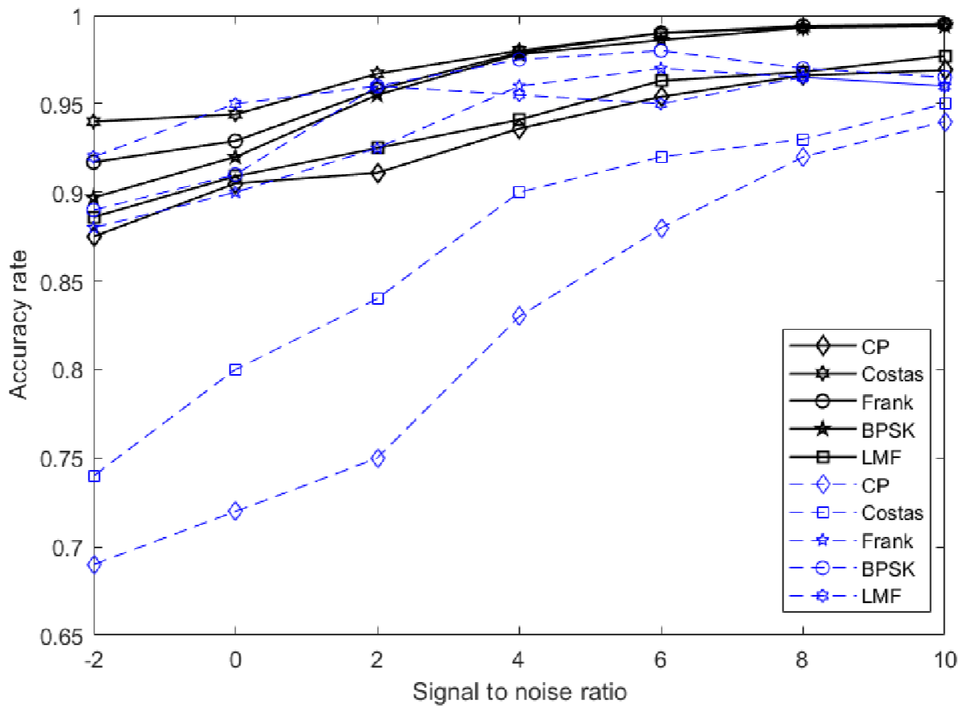

As can be seen from Figure 5 and Figure 6, compared with a single neural network, the classification system in this paper has a higher classification accuracy, especially for radar signals that are not easily distinguishable, and the accuracy is improved by about 10%, effectively reducing the problem of confusing signals with low recognition accuracy. Due to the strong nonlinear mapping ability, adaptive ability and generalization ability of BP neural network, it can accurately solve the complex mechanism inside the signal features and flexibly cope with noise interference. Besides, it also has certain fault tolerance ability to obtain better recognition results.

### 5. Conclusion

This paper proposes a radar signal classification method based on BP neural network, whose innovation lies in the effective combination of normalized PSD and BP neural network. This method can not only fully extract the information in PSD, but also make use of the powerful nonlinear mapping ability and flexible network structure of BP neural network.

In this paper, we constructed a complex echo signal, extracted features from its PSD, used the subband power ratio as the feature parameter, and used the BP neural network as the base learner for training to obtain the final classification results. The simulation experimental results show that the BP neural network can better distinguish different kinds of radar signals compared with the method of individual neural network training.

In the experiments of signal classification and recognition, the recognition rate can still reach more than 85% under the low signal-to-noise ratio, maintaining a good classification accuracy of radar signals. Meanwhile, the classification gap between different radar signals is reduced, with good stability and robustness. In addition, the classification method of this paper has certain superiority compared with similar single-layer neural networks. In summary, the radar signal recognition classification system constructed in this paper has high application value.

# References

Fan Boxuan, Chen Guiming, Chang Liang, Chang Dong and Zhao Zhe. (2021). Application Status and development trend of Lidar technology in military field. Aerospace Manufacturing Technology (03), 66-72.

Xu Runjun, Chen Xinxin. (2002). Application of Lidar in military. Physics and Engineering (06),3639.

LI Y J, XIAO P, WU H C, et al. LPI radar signal detection based on radial integration of ChoiWilliams time-frequency image[J]. Journal of Systems Engineering and Electronics, 2015, 26( 05): 973981.

HU H, WANG Y J, SONG J D. Signal classification based on spectral correlation analysis and SVM in cognitive radio[C]//Proceedings of 22nd International Conference on Advanced Information Networking and Applications (AINA 2008). Piscataway: IEEE Press, 2008: 883-887.

Dudul, S. V. (2007). Classification of radar returns from the ionosphere using rbf neural network. Journal of the Institution of Engineers (India). Electronics and Telecommunication Engineering Division (jul), 88.

Iglesias, Victor; Grajal, Jesus; Royer, Pablo; Sanchez, Miguel A.; Lopez-Vallejo, Marisa; Yesteojeda, Omar A. Real-time low-complexity automatic modulation classifier for pulsed radar signals [J]. IEEE TRANSACTIONS ON AEROSPACE AND ELECTRONIC SYSTEMS,2015,Vol.51(1): 108-126. [7] WANG Y C. Research on the modulation recognition algorithms and parameter estimation algorithms of radar signal [D]. Changsha: National University of Defense Technology, 2012. [8] WANG Q, DU P, YANG J, et al. Transferred deep learning based waveform recognition for cognitive passive radar [J]. Signal Processing, 2019, 155:259-267.

Wang Y L. (2018). Research on control of cyclic stationary characteristics of radar receiving signal. Computer Measurement and Control (07), 104-108. doi: 10.16526/j.cnki.11-4762/tp.2018.07.023. [10] Cao Yanfei, Yu Ligen, Teng Guanghui, Zhao Shumei & Liu Xuming. (2014). Feature extraction and classification recognition of sound and mechanical noise of laying hens. Transactions of the Chinese Society of Agricultural Engineering (18), 190-197.

Song Jianhong & Tian Jianhao. (2020). Waveform simulation and analysis of typical radar signals. China Radio (09), 38-40.

Cheng Jiwen, Wang Shusen, Luo Yuyang, & Zhang Ceng. (2022). Aboveground biomass prediction model of Salix salix based on BP neural network. Research in Forestry Science, Vol. 35, (3), 193-198. [13] Xu Rui, & Han Fengxia. (2021). Research progress and application of BP neural network in predicting housing prices along subway lines. Sichuan Building Materials, Vol. 47, (12), 172-175, 177. [14] Lang Rongling & Fan Ya. (2020). Analysis of the classification process of single layer neural network. Advanced Mathematics Research (05),45-47+50.